OUR ENVIROMENT

What we should, and shouldn´t do.

We shouldn´t waste water, because there is not infinite supplies of water, and we need to understand this, for example, we should take shorter showers instead of baths .

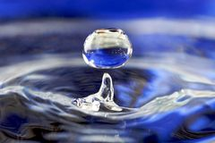

We should recycle rubbish, plastics, glass,paper etc. It´s so important to recycle, if not, the planet will be dirty and that will not look good for our future.

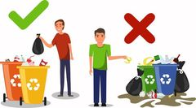

We should reuse plastic bottles or plastic bags, because they can be used not only once.

We should use both sides of paper, because people cut a lot of trees to make a paper from them, but we need trees more than paper.

We should plant some trees or flowers, because they make and oxygen for us.

We should walk instead going somewhere by car, it will be better I think.

Pollution

This is something what people do, but it is very bad, because a lot of animals die because people are cruel. As I wrote, we should recycle and throw the rubbish in the bin and I think that this little thing can save a lot of animals. So please don't be so cruel and help each other.

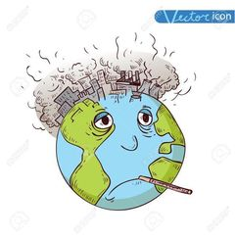Written by Ondřej Koziel, VIII.A

.